Worksheet

Ask better questions: From concern to clarity
In this worksheet, we will follow a step-by-step approach to asking the right questions, framing strong hypotheses, and knowing where to find the answers.
We will utilize this strategic process to gain more clarity.
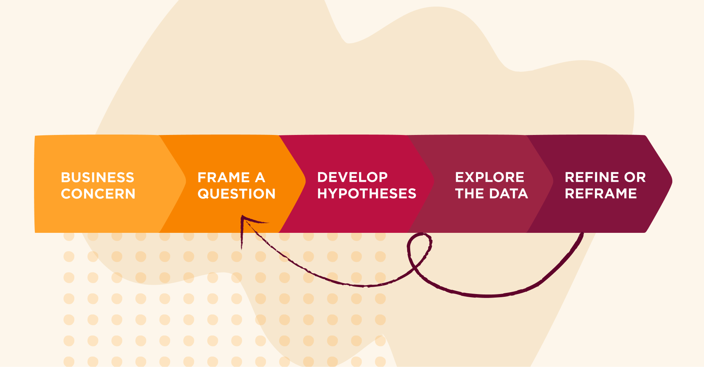
Follow the 6-step process below for more focused insights, more strategic recommendations, and clearer, stronger impact as an HR leader.
Let’s get started!

Step 1: Start with the business concern
Your goal in this step is to uncover the business tension that drives the request—not just what metric someone wants to see on a dashboard.
What’s the pain point? What outcome is at risk?
For example, if someone says “we need to reduce turnover,” you might ask:
What’s the impact of current turnover?
Where is it hurting the business most—customer outcomes, delivery timelines, morale?
Or: If we solve this, what changes for you?
This anchors your analysis in business impact.
Discovery is the process of turning vague concerns into clear, data-driven questions. That’s where great HR analysis begins.

Sample discovery questions include:

- What’s keeping you up at night right now?
- If this issue isn’t solved, what happens next quarter?
- What business outcome are we trying to shift?
- Where are we seeing friction—people, process, or priorities?
- What would ‘better’ look like for this team or function?
- How is that showing up day-to-day?

Example:
The Product team isn’t hitting their deadlines.
They tell you they’re understaffed.
That’s the observed business concern.

Activity:
Use the examples above to develop your own business concern. Write your answer in the Business concern column.

Business concern | Frame a question | Develop hypotheses | Explore the data | Refine or reframe
How is staffing influencing product delivery?

Step 2: Frame a clear, specific question
Framing your question is where HR analytics goes from tactical to strategic.
Use applied questions that tie directly to business concerns, like productivity, retention, or cost, not academic ones. Ask yourself what problem needs to be solved, rather than what data is available.
Use first-order questions. Don’t jump to the ‘why’ until you understand the ‘what.’
- What’s happening?
- Where is it happening?
- With or to whom is it happening?
Define one unifying research question that ties all your smaller data explorations together.
For example, if you’re investigating training effectiveness, the core question might be:
Is our training improving employee performance and retention?
Then you can break that down:
- Who received training?
- How did their performance change?
- Did they stay longer than those who didn’t?

Example:
Your product team isn’t hitting their deadlines, and they think they are understaffed.
So you frame this question:

How is staffing influencing product delivery?

Activity:
Use the examples above to formulate a question. Your question should be applied, first-order, and directly tied to a business need.
Put the question you formulate in the Frame the question column.

Business concern | Frame a question | Develop hypotheses | Explore the data | Refine or reframe
Product isn’t hitting deadlines.  Claim they are understaffed. | How is staffing influencing product delivery?

Step 3: Form the hypotheses
Before diving into the data, it’s critical to pause and ask:
What do we think might be happening here? What might be driving this?
That’s where your hypotheses come in. They are educated guesses you can test with data.
Without a hypothesis, you’re searching in the dark.
With one, you’re following a map.
Here’s how to build a hypothesis that you can follow:
- Start with your question: How is staffing influencing product delivery?
- List 2–3 possible causes. Maybe it’s inconsistent onboarding. Maybe the job was misrepresented. Maybe the team culture is driving people out.
This will give your analysis direction, structure, and purpose.

Example:
Based on the example question How is staffing influencing product delivery?, here are a few hypotheses we can make:
- Are we hiring too slowly?
- Are we hiring the wrong people?
- Are people leaving too soon?

Activity:
Use your own question from Step 2, then list 2–3 possible causes. Place all your causes, or hypotheses, in the Develop hypotheses column.

Business concern | Frame a question | Develop hypotheses | Explore the data | Refine or reframe
Product isn’t hitting deadlines.  Claim they are understaffed. | How is staffing influencing product delivery? | Are we hiring too slowly?  Are we hiring the wrong people?  Are people leaving too soon?

Step 4: Find the right data sources
Ask yourself, “Where can I find the information I need?

Your HRIS is a goldmine of structured information and data on tenure, time-to-hire, turnover, and other key metrics. Use surveys, pulse tools, and even performance reviews to gauge what people are feeling and experiencing on a daily basis.

Try to go beyond HR data. Look across systems, teams, and even outside your org to build a full picture. Some of the most valuable insights come from cross-functional partners, such as Finance and Sales.
Remember to check:
- Is your data accurate, consistent, and complete?
- Is it capable of answering the question you need it to answer?
As you explore your data, remember:
- Triangulation gives you a fuller picture
- Your business question is the filter

Example:
Based on the hypotheses in the example above, you start to check your HR system:
- Time-to-hire and headcount trends
- Performance feedback from recent hires
- Exit data and first-year attrition reports
But before jumping to conclusions, you check the data quality:
- Are fields complete?
- Are labels consistent across systems?
- Is the data current and accurate?
You begin exploring the data, and you uncover these insights:
- Hiring speed looks solid
- Hiring quality is high. People are capable and well-regarded
- First-year turnover is high. People often leave within 6 to 9 months
💡The root issue isn’t hiring, it’s retention.

Activity:
Go through the data sources you have, and use your business question as the filter. Add your insights to the Explore the data column.

Business concern | Frame a question | Develop hypotheses | Explore the data | Refine or reframe
Product isn’t hitting deadlines.  Claim they are understaffed. | How is staffing influencing product delivery? | Are we hiring too slowly?  Are we hiring the wrong people?  Are people leaving too soon? | Hiring speed - good  Hiring quality - good  First-year turnover is high  Insight: retention

Step 5: Analyze and refine
Let the data challenge your assumptions. If a hypothesis doesn’t pan out, don’t stop entirely, just ask a more targeted question.

Example:
In the last step, you discovered that the root issue isn’t hiring—it’s retention.
So now you ask a new question:
What’s driving early exits on the product team?

Activity:
Reframe your question based on your discovery or insight, and put your new question in the Refine or reframe column.

Business concern | Frame a question | Develop hypotheses | Explore the data | Refine or reframe
Product isn’t hitting deadlines.  Claim they are understaffed. | How is staffing influencing product delivery? | Are we hiring too slowly?  Are we hiring the wrong people?  Are people leaving too soon? | Hiring speed - good  Hiring quality - good  First-year turnover is high  Insight: retention | Reframe question:  What is driving early exits on the product team?

Step 6:
This is now an iterative process between steps 2 and 5.
Use a blank table to begin again with Step 2.
Business concern | Frame a question | Develop hypotheses | Explore the data | Refine or reframe

Activity:
Write your new question in the Frame the question column.
Business concern | Frame a question | Develop hypotheses | Explore the data | Refine or reframe
Product isn’t hitting deadlines.  Claim they are understaffed. | What is driving early exits on the product team? | Is it workload or burnout?  Management style?  Career path clarity?
Continue with steps 3, 4, and 5, refining and rephrasing questions until you get closer to the root cause. Each round of inquiry gets you closer to an action that will make a difference.

